**JUCC Competition Platform**

# **Slides summary**

|  |  |
| --- | --- |
| **CTF platform** | Description |
| [PicoCTF](https://picoctf.org/) | 1. Educational platform: picoCTF is a free, online cybersecurity competition for middle and high school students. 2. Gamified learning: It offers a series of challenges that teach hacking techniques through engaging gameplay. 3. Skill development: Students learn reverse engineering, cryptography, web exploitation, and binary exploitation through hands-on challenges. |
| [HackTheBox](https://www.hackthebox.com/) | 1. Penetration Testing Playground: HackTheBox is an online platform for testing and advancing cybersecurity skills. 2. Real-world Scenarios: It provides virtual machines and challenges that simulate real-world hacking scenarios. 3. Community-driven: Users can create and share their own challenges, fostering a collaborative learning environment. |
| [Pwn.college](https://pwn.college/) | 1. Academic focus: pwn.college is an educational platform designed for university-level cybersecurity education. 2. Structured Curriculum: It offers a comprehensive, semester-long course covering various aspects of offensive security. 3. Practical Exercises: Students engage in hands-on exercises to learn exploitation techniques and defensive strategies. |
| [FlagYard](https://flagyard.com/) | 1. CTF platform: Flagyard is a Capture The Flag platform focusing on web security challenges. 2. Web exploiation: It offers a range of web-based challenges to improve hacking skills. 3. Community driven: Users can create and share their own challenges, fostering collaborative learning. |
| [CTF101](https://ctf101.org/) | 1. Beginner friendly: CTF101 is an introductory platform for those new to Capture The Flag competitions. 2. Foundational knowledge: It provides basic concepts and techniques essential for participating in CTF events. 3. Guided learning: The platform offers step-by-step tutorials and resources for various CTF categories. |

|  |  |  |  |  |
| --- | --- | --- | --- | --- |
| CTF platform | Target Audience | Focus Area | Challenge Types | Type |
| [PicoCTF](https://picoctf.org/) | Students | General Cybersecurity | Varied | Freemium |
| [HackTheBox](https://www.hackthebox.com/) | Professionals | Penetration Testing | Machine Hacking | Premium |
| [Pwn.college](https://pwn.college/) | University Students | Offensive Security | Structured Courses | Freemium |
| [FlagYard](https://flagyard.com/) | Web Security Enthusiasts | Web Exploitation | Web Challenges | Freemium |
| [CTF101](https://ctf101.org/) | Beginners | CTF Basics | Introductory Challenges | Freemium |

# **Researches**

**Development of a Platform for Learning Cybersecurity Using Capturing the Flag Competitions**

[Link](https://www.mdpi.com/2078-2489/12/8/318)

**Open Source and Commercial Capture The Flag Cyber Security Learning Platforms - A Case Study**

[Link](https://ieeexplore.ieee.org/document/9527941)

**A comprehensive cybersecurity learning platform for elementary education**

[Link](https://www.tandfonline.com/doi/abs/10.1080/19393555.2019.1657527)

**A Capture The Flag (CTF) Platform and Exercises for an Intro to Computer Security Class**

[Link](https://dl.acm.org/doi/abs/10.1145/3502717.3532153)

**A COMPARISON STUDY OF TWO CYBERSECURITY LEARNING SYSTEMS: FACEBOOK’S OPEN SOURCE CAPTURE THE FLAG AND CTFD**

[Link](https://iacis.org/iis/2020/1_iis_2020_202-212.pdf)

**Open Source and Commercial Capture The Flag Cyber Security Learning Platforms: A Case Study**

[Link](https://pure.port.ac.uk/ws/portalfiles/portal/42722402/Capture_the_flag.pdf)

**An Analysis and Evaluation of Open Source Capture the Flag Platforms as Cybersecurity e-Learning Tools**

[Link](https://www.researchgate.net/profile/Stylianos-Karagiannis/publication/344372369_An_Analysis_and_Evaluation_of_Open_Source_Capture_the_Flag_Platforms_as_Cybersecurity_e-Learning_Tools/links/5fc164d1299bf104cf86cd75/An-Analysis-and-Evaluation-of-Open-Source-Capture-the-Flag-Platforms-as-Cybersecurity-e-Learning-Tools.pdf?origin=publication_detail)

**CTFd Pricing**

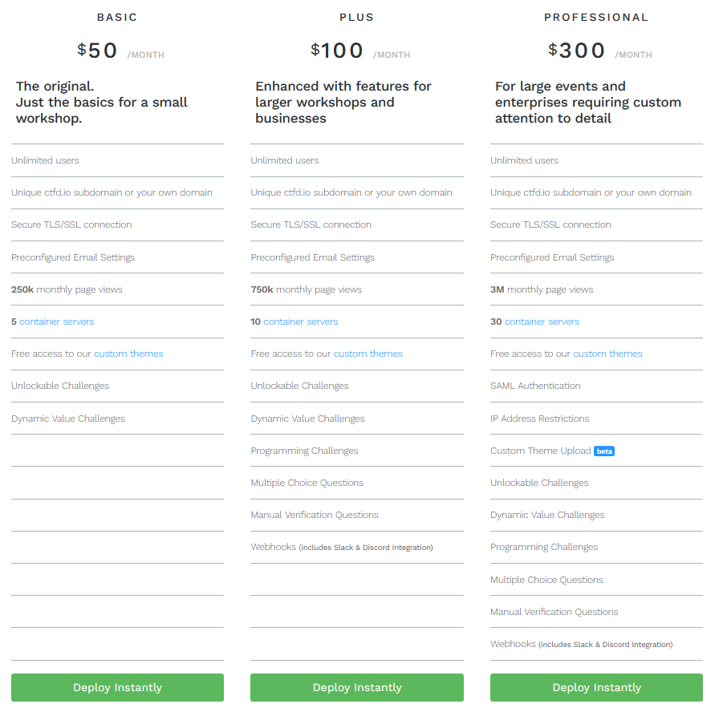

**Google Cloud Instance Pricing.**

[**Using a pricing calculator.**](https://cloud.google.com/products/calculator?hl=en&dl=CjhDaVF3TW1JMk1XWXlOaTB3TVRVMExUUTVabUV0WWpCbE9TMDVaVFprTURreVpESmxPV0VRQVE9PRAIGiRCNEM2QTg1RC1ERDFELTRCQkQtQjYwOS1DMDI4REI2OUQyODc)

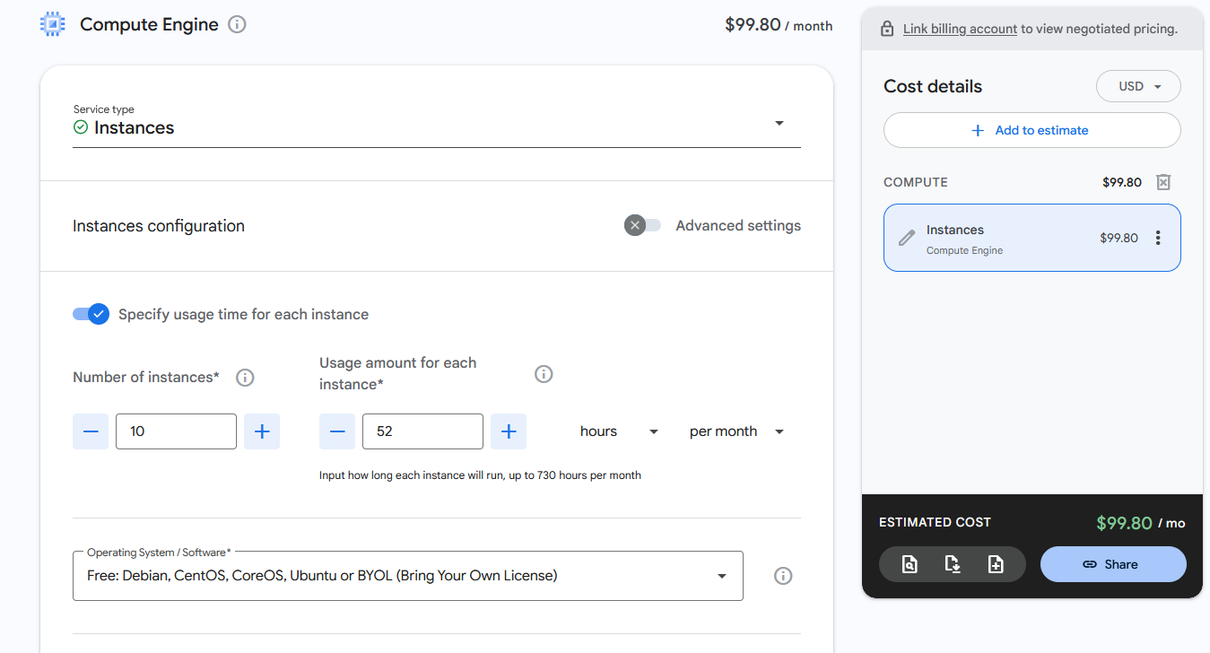

**Project Diagram**

